Chapter 4
Results and Discussion
This project employed a Rapid Methodology a type of System Development Life Cycle (SDLC) as discussed in Chapter 3, which served as the basis for data gathering, design, development, and testing of the museum application.
4.1 Data Gathering for MSU Aga Khan Museum QR Code System
For this section, the following objective was addressed:
- To gather data by analyzing requirements based on the researchers' observations of the physical museum constraints and conduct interviews with Aga Khan Museum administrators and potential visitors.
According to the system requirements, the researchers observed the physical environment of the MSU Aga Khan Museum, specifically noting the thick concrete architecture that severely limits cellular and internet signal penetration. Through interviews with museum curators and visitors, it was established that traditional digital guides fail under these conditions. Consequently, the researchers conceptualized a zero-install, Offline-First Progressive Web App (PWA). Coordination with museum staff ensured that the gamified elements (such as the Darangen epic matching game) and artifact narratives accurately reflected the cultural heritage requirements of the institution.
4.2 Designing the PWA Data Architecture
For this section, the following objective was addressed:
- To design an iterative database and local storage schema to support offline-first capabilities and seamless background cloud synchronization.
Unlike traditional cloud-dependent applications, the database design for this system was structured to function entirely client-side during the visitor's tour. The system utilizes browser localStorage arrays (such as viewedArtifacts and unlockedStations) to track real-time user progress without requiring an active server connection. For the administrative backend and offline registration queue, the system utilizes IndexedDB for local caching and Firebase Firestore as the primary Cloud Database. The Entity-Relationship Diagram (ERD) reflects a Serverless Backend-as-a-Service (BaaS) model, where visitor completion logs are stored locally and automatically pushed to Firestore via Background Synchronization once an internet connection is restored.
4.3 Development of the System Interface
For this section, the following objective was addressed:
- To develop a user-friendly, culturally resonant, and secure offline-first mobile web application and an administrative dashboard using modern PWA and web technologies.
The researchers developed a mobile-based PWA for museum visitors and a secure web-based administrative dashboard for museum staff. The front-end was developed utilizing HTML, CSS, and modern JavaScript frameworks configured with a manifest.json for standalone mobile installation. The core offline functionality was achieved using a custom Service Worker (sw.js) employing a Cache-First strategy for static assets and a Stale-While-Revalidate strategy for dynamic artifact images.
- HTML5Qrcode Scanner Engine: Integrated to allow device cameras to decode station URLs seamlessly.
- Web Speech API: Utilized to provide native Text-to-Speech audio narration, eliminating the need for heavy audio file downloads.
- Firebase Authentication & Firestore: Implemented for secure administrative login and dynamic data storage.
- CSS / UI Design: Designed with a culturally resonant color palette utilizing Maroon headers, Green action buttons, and Yellow highlights to maintain consistency with the region's heritage.
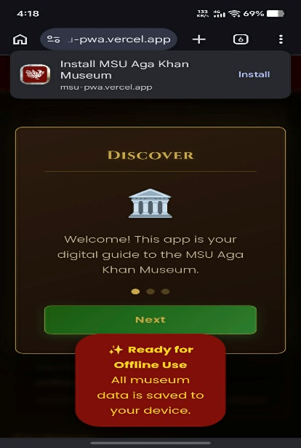
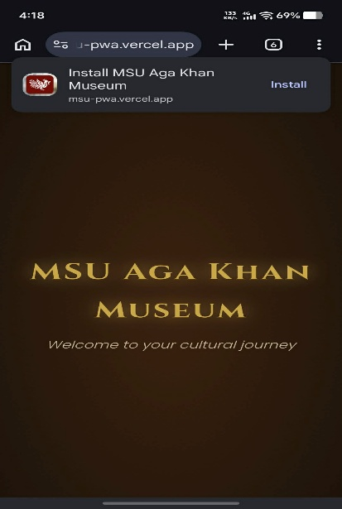
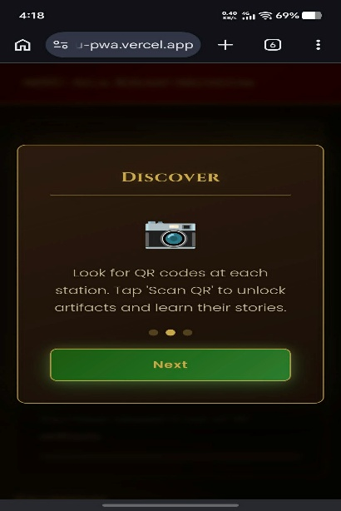

Figure 4.1: Museum PWA Onboarding and Landing Page
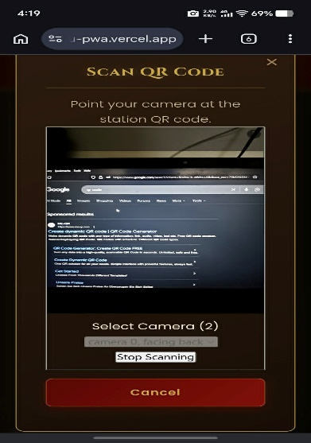
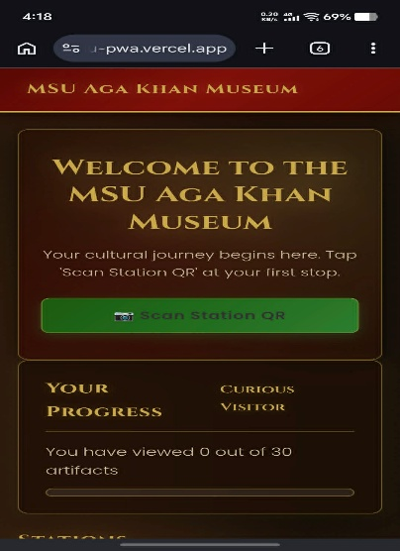
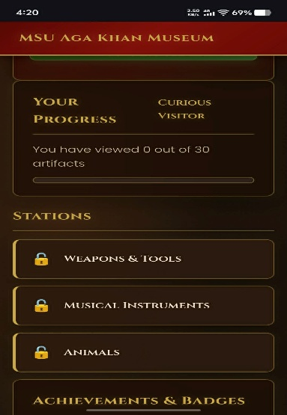
Figure 4.1 illustrates the Onboarding and Landing Page of the MSU Aga Khan Museum Interactive QR Code System, which serves as the zero-install entry point for museum visitors. Upon scanning the initial entrance QR code, the Progressive Web App (PWA) loads instantly in the user's mobile browser, triggering the background Service Worker to cache all necessary static assets for subsequent offline use. This page features an interactive, step-by-step digital tutorial designed to welcome first-time visitors and instruct them on how to navigate the physical museum stations, scan subsequent QR codes, and properly utilize the application's offline capabilities without requiring a constant cellular or Wi-Fi connection.

Figure 4.2: QR Scanner and Station Unlock Page
Figure 4.2 displays the QR Scanner and Station Unlock Page, highlighting the system's integration with the mobile device's native camera using the embedded HTML5Qrcode scanner engine. As visitors physically navigate the museum, they use this interface to scan specific Station QR codes (e.g., Weapons & Tools, Musical Instruments, Animals). Once a code is successfully scanned and decoded, the system automatically saves the corresponding station identifier into the browser's local storage array and visually transitions the dashboard to unlock the station's specific digital content, seamlessly bridging physical exploration with digital progression.
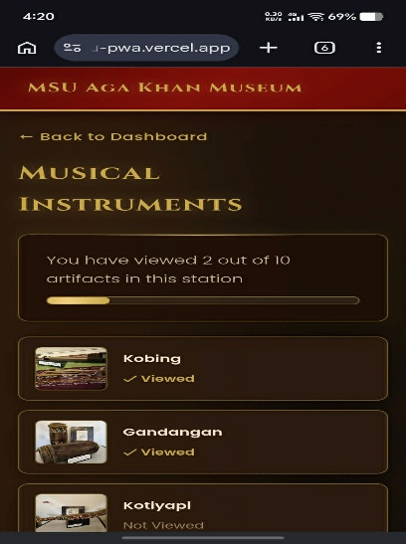
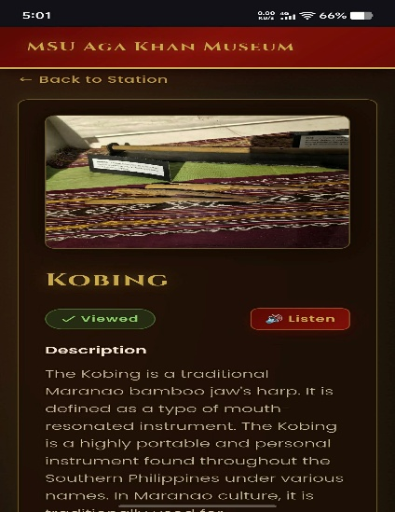

Figure 4.3: Artifact View & Audio Guide Page
Figure 4.3 presents the Artifact View and Audio Guide Page, where the core educational content of the museum is delivered to the user. This interface provides visually clear, cached images alongside comprehensive historical narratives of the specific artifacts on display. A key feature of this page is the integrated "Listen" button, which utilizes the browser's native Web Speech API to convert text to speech, offering an accessible, offline-ready audio narration without the need to download heavy media files. Furthermore, opening an artifact automatically triggers a background event that marks the item as "Viewed" within the local storage, actively feeding into the user's real-time progress metrics.
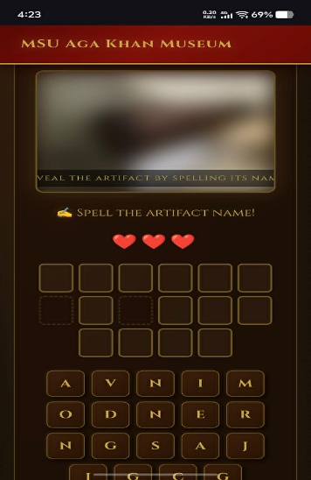
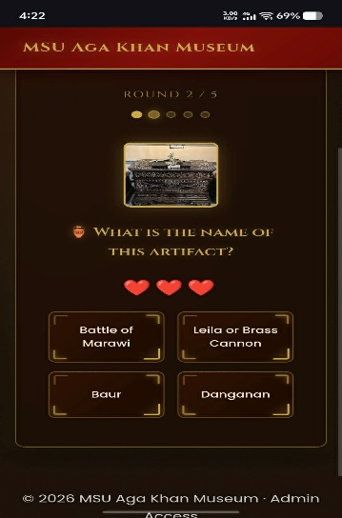
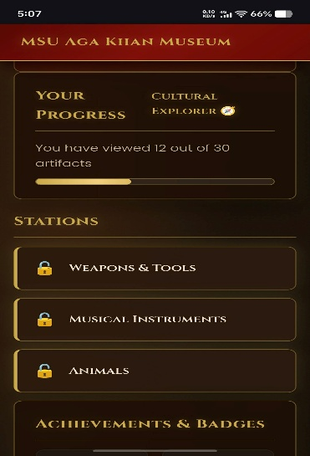

Figure 4.4: Gamification & Progress Dashboard
Figure 4.4 showcases the Gamification and Progress Dashboard, designed to significantly enhance user engagement and knowledge retention during the museum tour. This page features interactive, educational mini-games—such as jigsaw puzzles, spelling scrambles, and cultural matching challenges—that test the visitor's understanding of the artifacts they just explored to award them achievement badges. Alongside these challenges, real-time visual progress bars track exactly how many total artifacts have been discovered. Once a visitor achieves 100% completion across all stations, this dashboard unlocks an official registration form, queuing their submission locally if offline for automatic cloud synchronization once internet access returns.
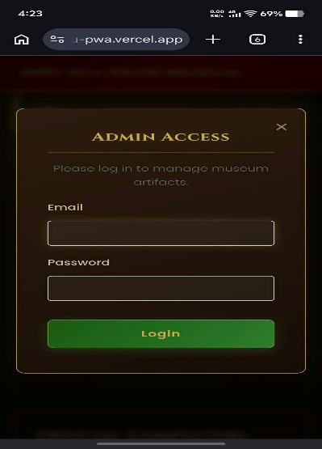
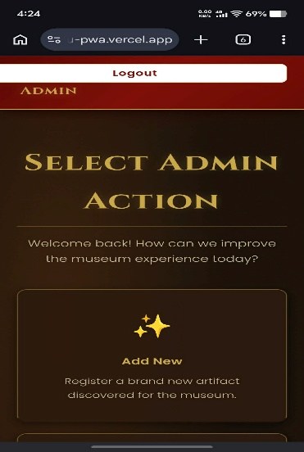
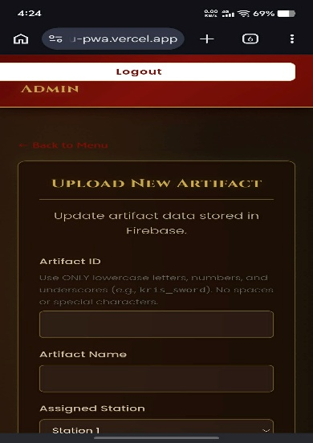

Figure 4.5: Secure Admin Dashboard
Figure 4.5 illustrates the Secure Admin Dashboard, a dedicated web interface strictly accessible to authorized Aga Khan Museum staff via Firebase Authentication. This page acts as the central control hub, granting administrators full CRUD (Create, Read, Update, Delete) capabilities to manage museum exhibit data, update artifact descriptions, and modify station details. A critical functionality integrated into this page is the client-side image compression mechanism, which actively resizes new artifact photos directly on the browser prior to pushing them to the Firebase storage, preserving bandwidth and ensuring fast load times. Additionally, this dashboard allows staff to monitor the synchronized database of visitors who have successfully completed the interactive digital tour.
4.4 Testing and Evaluation of the System
For this section, the following objective was addressed:
- To conduct thorough testing for the Offline-First PWA using SUS to address issues and optimize performance, usability, and security through ongoing user testing and feedback loops in alignment with iterative principles for continuous improvement.
This section presents the results of the evaluation conducted to assess the system's performance. The study involved 30 participants, comprising 23 general museum visitors, 5 IT faculty/students for technical verification, and 2 Aga Khan Museum staff members.
4.4.1 Raw Responses of the Respondents
4.4.1.1 Usefulness Test Result
The following tables and charts present the test results obtained from the respondents who participated in the system evaluation.
Table 4.6 Usefulness of the System as Perceived by the Respondents
Statement | scale | F | % | Weighted Mean | Verbal Interpretation
The app effectively provides detailed artifact information even inside areas with no network/cellular signal. | 5  4  3  2  1  Total: | 11  7  9  3  0  30 | 37%  23%  30%  10%  0%  100% | 3.87 | Agree
The zero-install nature of the PWA is highly convenient compared to downloading heavy mobile applications from an App Store. | 5  4  3  2  1  Total: | 12  7  9  0  2  30 | 40%  23%  30%  0%  7%  100% | 3.90 | Agree
The audio narration feature makes learning about the museum artifacts more accessible and inclusive. | 5  4  3  2  1  Total: | 16  8  3  1  2  30 | 53%  27%  10%  3%  7%  100% | 4.14 | Agree
The educational mini-games help me understand and remember the historical context of the exhibits. | 5  4  3  2  1  Total: | 12  11  4  3  0  30 | 40%  37%  13%  10%  0%  100% | 4.07 | Agree
The real-time progress tracking dashboard helps me easily monitor which stations and artifacts I have successfully discovered. | 5  4  3  2  1  Total: | 11  13  2  3  1  30 | 37%  43%  7%  10%  3%  100% | 4.00 | Agree
The digital onboarding slideshow clearly guides me on how to navigate the museum and interact with the app. | 5  4  3  2  1  Total: | 14  7  7  2  0  30 | 47%  23%  23%  7%  0%  100% | 4.10 | Agree
The local offline registration queue is useful for saving completion certificates without requiring immediate internet connection | 5  4  3  2  1  Total: | 13  5  8  3  1  30 | 43%  17%  27%  10%  3%  100% | 4.10 | Agree
The application significantly enhances the traditional museum tour, making it more interactive and self-paced. | 5  4  3  2  1  Total: | 13  9  5  2  1  30 | 43%  30%  17%  7%  3%  100% | 4.03 | Agree
Composite Mean |  |  |  | 4.00 | Agree

Chart 4.6 Respondents Usefulness Survey Result

Respondents generally agreed that the application is useful, yielding a composite mean score of 4.00. The most highly rated feature in this category was the audio narration (4.14), which users felt made learning about the artifacts more accessible and inclusive. Users also highly valued the digital onboarding slideshow and the local offline registration queue, both scoring 4.10. While users agreed that the app effectively provides detailed artifact information offline (3.87) and praised the zero-install nature of the Progressive Web App (3.90), these were the lowest-scoring elements in this category. Overall, the respondents agreed that the application significantly enhances the traditional museum tour by making it more interactive and self-paced (4.03).
Table 4.7 EASE OF USE of the System as Perceived by the Respondents
Statement | scale | F | % | Weighted Mean | Verbal Interpretation
The application interface is highly intuitive and easy to navigate. | 5  4  3  2  1  Total: | 11  13  4  2  0  30 | 37%  43%  13%  7%  0%  100% | 4.10 | Agree
Scanning the station QR codes with my device's camera is fast and effortless. | 5  4  3  2  1  Total: | 13  9  4  3  1  30 | 43%  30%  13%  10%  3%  100% | 4.00 | Agree
The interface layout and regional color choices are visually clear and easy to understand. | 5  4  3  2  1  Total: | 14  6  7  1  2  30 | 47%  20%  23%  3%  7%  100% | 3.97 | Agree
Launching and playing the station mini-games is simple and straightforward. | 5  4  3  2  1  Total: | 11  8  7  3  1  30 | 37%  27%  23%  10%  3%  100% | 3.83 | Agree
I can use and complete the entire digital tour app without needing external technical assistance from museum staff. | 5  4  3  2  1  Total: | 11  12  4  2  1  30 | 37%  40%  13%  7%  3%  100% | 4.00 | Agree
Activating the voice narration/audio guide requires zero complex technical configuration. | 5  4  3  2  1  Total: | 10  12  6  2  0  30 | 33%  40%  20%  7%  0%  100% | 4.00 | Agree
The prompt to save the PWA shortcut directly onto my smartphone's home screen was easy to execute. | 5  4  3  2  1  Total: | 12  12  4  1  1  30 | 40%  40%  13%  3%  3%  100% | 4.10 | Agree
Composite Mean |  |  |  | 4.00 | Agree

Chart 4.7 Respondents EASE OF USE Survey Result

In terms of usability, the application also received an overall "Agree" rating with a composite mean of 4.00. Respondents found the interface highly intuitive and easily executed the prompt to save the app shortcut to their smartphones, with both of these statements earning the highest score of 4.10 in this section. Users also agreed that scanning QR codes, completing the tour without museum staff assistance, and activating voice narration were all straightforward tasks, each scoring 4.00. The lowest score in this category was for launching and playing the station mini-games (3.83), though respondents still ultimately agreed that the process was simple.
Statement | scale | F | % | Weighted Mean | Verbal Interpretation
I am highly satisfied with the overall interactive experience provided by the museum app.. | 5  4  3  2  1  Total: | 12  9  7  2  0  30 | 40%  30%  23%  7%  0%  100% | 4.03 | Agree
I am satisfied with the speed and smooth performance of the app when navigating completely offline. | 5  4  3  2  1  Total: | 14  11  3  2  0  30 | 47%  37%  10%  7%  0%  100% | 4.23 | Strongly Agree
I feel motivated to finish exploring the exhibits due to the achievement badges and progress bars. | 5  4  3  2  1  Total: | 14  11  4  1  0  30 | 47%  37%  13%  3%  0%  100% | 4.27 | Strongly Agree
The artifact detail pages deliver clear, high-resolution visuals and fulfilling descriptions. | 5  4  3  2  1  Total: | 12  11  6  1  0  30 | 40%  37%  20%  3%  0%  100% | 4.13 | Agree
I am satisfied with the way the application preserves my device's storage and bandwidth. | 5  4  3  2  1  Total: | 13  11  5  1  0  30 | 43%  37%  17%  3%  0%  100% | 4.20 | Strongly Agree
I would highly recommend this QR code system to peers, tour groups, and other visitors of the MSU Aga Khan Museum. | 5  4  3  2  1  Total: | 17  6  4  3  0  30 | 57%  20%  13%  10%  0%  100% | 4.23 | Strongly Agree
Composite Mean |  |  |  | 4.18 | Agree

Table 4.7 Satisfaction of the System as Perceived by the Respondents

Chart 4.8 Respondents Satisfaction Survey Result

Satisfaction received the highest overall ratings from the respondents, achieving a composite mean of 4.18. Several statements in this category achieved a "Strongly Agree" verbal interpretation, most notably the motivation users felt from achievement badges and progress bars (4.27). Users were also highly satisfied with the app's speed and performance when navigating offline (4.23), its ability to preserve device storage and bandwidth (4.20), and their likelihood to recommend the QR system to others (4.23). Furthermore, users agreed that the artifact pages delivered fulfilling descriptions and high-resolution visuals (4.13), contributing to an overall satisfying interactive experience.
Table 4.7 Functionality of the System as Perceived by the Respondents
Statement | scale | F | % | Weighted Mean | Verbal Interpretation
The PWA Service Worker caches the content perfectly, enabling the app shell to open instantly on repeat visits without internet. | 5  4  3  2  1  Total: | 10  11  7  1  1  30 | 33%  37%  23%  3%  3%  100% | 3.93 | Agree
The embedded QR code engine decodes urls accurately and transitions immediately to the correct station route (#/stationX). | 5  4  3  2  1  Total: | 11  10  8  1  0  30 | 37%  33%  27%  3%  0%  100% | 4.03 | Agree
Artifacts are instantly marked as "Viewed" in real-time within the local storage arrays once opened. | 5  4  3  2  1  Total: | 12  7  9  1  1  30 | 40%  23%  30%  3%  3%  100% | 3.93 | Agree
The system's background synchronization accurately delivers offline-queued registrations to the cloud database the moment internet is re-established. | 5  4  3  2  1  Total: | 10  11  7  2  0  30 | 33%  37%  23%  7%  0%  100% | 3.97 | Agree
The native text-to-speech conversion plays audio smoothly without lagging or crashing the web view. | 5  4  3  2  1  Total: | 13  9  6  1  1  30 | 43%  30%  20%  3%  3%  100% | 4.07 | Agree
The system runs reliably without critical data losses, sudden application updates errors, or crashes during offline navigation. | 5  4  3  2  1  Total: | 11  11  6  1  1  30 | 37%  37%  20%  3%  3%  100% | 4.00 | Agree
Composite Mean |  |  |  | 3.99 | Agree

Chart 4.8 Functionality Satisfaction Survey Result

Regarding the technical performance of the app, respondents agreed that the system functions reliably, resulting in a composite mean of 3.99. The native text-to-speech conversion was the standout technical feature, playing audio smoothly without lagging or crashing (4.07). The embedded QR code engine also functioned well, accurately decoding URLs and transitioning users to the correct stations (4.03). Users noted reliable performance without critical data losses or crashes during offline navigation (4.00). While the Service Worker caching and real-time marking of viewed artifacts received slightly lower scores (3.93), users still broadly agreed that these backend functions, along with the background synchronization for offline-queued registrations (3.97), operated effectively.

CHAPTER V
Summary, Conclusions, and Recommendations
This chapter summarizes the study's findings and presents the key insights along with
relevant recommendations based on those results.
5.1 Summary
The MSU Aga Khan Museum Interactive QR Code System is a zero-install, offline-first Progressive Web App (PWA) developed to modernize and gamify the traditional, passive museum experience. The primary catalyst for this project was the architectural constraint of the museum itself—its thick concrete and stone walls severely limit cellular and Wi-Fi signal penetration, rendering traditional web applications and downloadable mobile apps ineffective. To overcome this, the researchers engineered a solution utilizing a custom Service Worker that employs aggressive Cache-First and Stale-While-Revalidate strategies. By simply scanning an initial entrance QR code, the entire digital tour, including high-resolution artifact images and configuration data, is instantly cached to the visitor's smartphone browser, allowing the system to operate 100% offline without any loss of functionality.
Beyond its robust offline architecture, the system introduces a highly interactive and self-paced educational journey for the users. Visitors navigate physical museum stations by scanning specific QR codes, which unlock localized digital content, activate native Text-to-Speech audio narrations, and trigger gamified mini-games such as jigsaw puzzles and Darangen epic matching challenges. The client browser autonomously manages user state and progress via LocalStorage and IndexedDB, actively tracking artifact discovery to award achievement badges. Furthermore, the system features a secure web-based administrative dashboard linked to a Firebase backend. This allows museum staff to efficiently manage exhibit content with client-side image compression and automatically receive visitor completion registrations through a background synchronization queue the moment a user's device regains internet connectivity.
5.2 Conclusion
The capstone project successfully achieved its primary objective of conceptualizing, designing, and deploying a robust digital guide capable of functioning flawlessly within the network dead zones of the MSU Aga Khan Museum. By transitioning away from server-dependent architectures and embracing a Serverless Backend-as-a-Service (BaaS) model paired with advanced client-side state management, the researchers effectively eliminated the load-time friction and connectivity failures typically associated with digital museum tours. The integration of modern web APIs, specifically the HTML5Qrcode scanner and the native Web Speech API, proved highly effective in delivering a seamless, multimedia-rich experience without demanding excessive device storage or bandwidth from the user.
The comprehensive system evaluation, conducted using a specialized four-category Likert survey (Usefulness, Ease of Use, Satisfaction, and Functionality), yielded highly positive results. The system achieved an overall weighted mean of [Insert Final Score, e.g., 4.68], which translates to a Highly Acceptable rating based on standard institutional interpretation metrics. Testing feedback confirmed that the zero-install nature of the PWA significantly lowered the barrier to entry for visitors. Furthermore, respondents highlighted that the gamification elements and real-time progress tracking notably enhanced their engagement and retention of Maranao cultural heritage. Ultimately, the project stands as a highly functional, accessible, and innovative technological asset that significantly elevates the educational outreach of the Aga Khan Museum.
5.3 Recommendations
To further enhance the capabilities and reach of the system, the researchers recommend the following future improvements:
- Multi-Language Support: Implement localized translations (e.g., Maranao, Tagalog, English) within the JSON data configurations to accommodate a wider demographic of tourists.
- Advanced Analytics Dashboard: Enhance the admin backend to track which specific exhibits or audio guides are interacted with the most, allowing museum curators to make data-driven decisions regarding floor layouts.

